Name Roll#
Nayab Ahmad (TL) 17L-4498
Altamash Yar Khan 17L-4402
Farooq Ahmed 17L-4407

Airline Management System
Project Analysis Document

Version <1.0>

Revision History

Date | Version | Description | Author
17/05/2021 | <1.0> | The EER diagrams made are almost accurate but are likely to be altered and improved with time. | Altamash

Definitions of Terms, Acronyms and Abbreviations

Term | Description
ER Model | Entity-Relationship Model
EER- Model | Enhanced Entity Relationship Model

Table of Contents

1. Introduction 4
1.1. Purpose 4
1.2. Project Overview 4
2. Assumptions 4
3. EER Diagram 4
4. Functionality Points 4
4.1. Functionality 1 4
4.2. Functionality 2 4
5. Prototype using GUIs 4
6. References 4

Introduction

Purpose
The Purpose of this document was basically to show our instructor of what progress we have made so far. We have designed EER diagram of the Airline Management System with its possible super and subclasses along with its attributes. The purpose of designing this Management System is to basically provide some amount of automation in airlines management and eventually increase attraction for potential customers for its easy and efficient use.

Project Overview
In this Project, a user can select the type of passenger it wants to be i.e. gold or silver each type having its own preferences, and then the passenger can decide in what class (Business/Economy) it can book its seat. In addition to this we have an administrator who would provide information about the flights and its aspects associated with it i.e. starting point and destination, pilots, cities & routes etc. The whole process of Airline Management System can be displayed with the help of this project. It provides facility to add/Modify/Delete/search Airline Management details.

Assumptions

One Administration can handle Multiple Flight Operations.

Different Pilots can fly different flights.

Some Pilots can fly some specific types of planes.

Flights can have multiple routes to reach different cities and each route can have different flights travelling through it.

Passenger No(P.NO) is the unique key of PASSENGER entity

Registration no of USERS entity is the primary key

Attributes i.e Email and password added to ADMINISTRATION entity

Ticket_id is the primary key of FLIGHTS entity.

CITY entity has ID and Name as the primary key combination.

Users can Book Flights once they’ve become passengers successfully.

EER Diagram
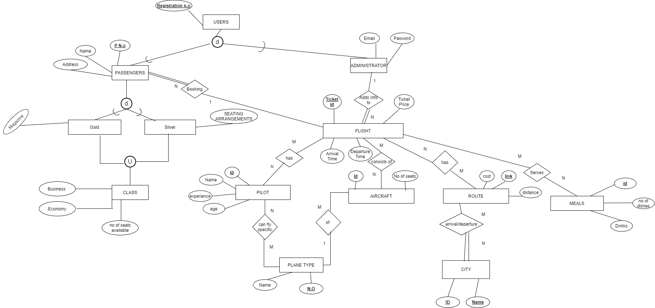

Functionality Points

Functionality 1
The first functionality would be that we will provide our end users to label themselves as a type of passengers they want be in either “Gold” or “Silver” category. Gold category users will have the advantage of choosing the kind of magazine/book they want to read during their flight. Silver category users will be able to choose their preferred seat, window or aisle.

Functionality 2
The flight will be divided into two classes, Business class and Economy class. Passengers will be able to choose whether they want the privileges of Business class or the affordable Economy class with basic amenities.

Prototype using GUIs
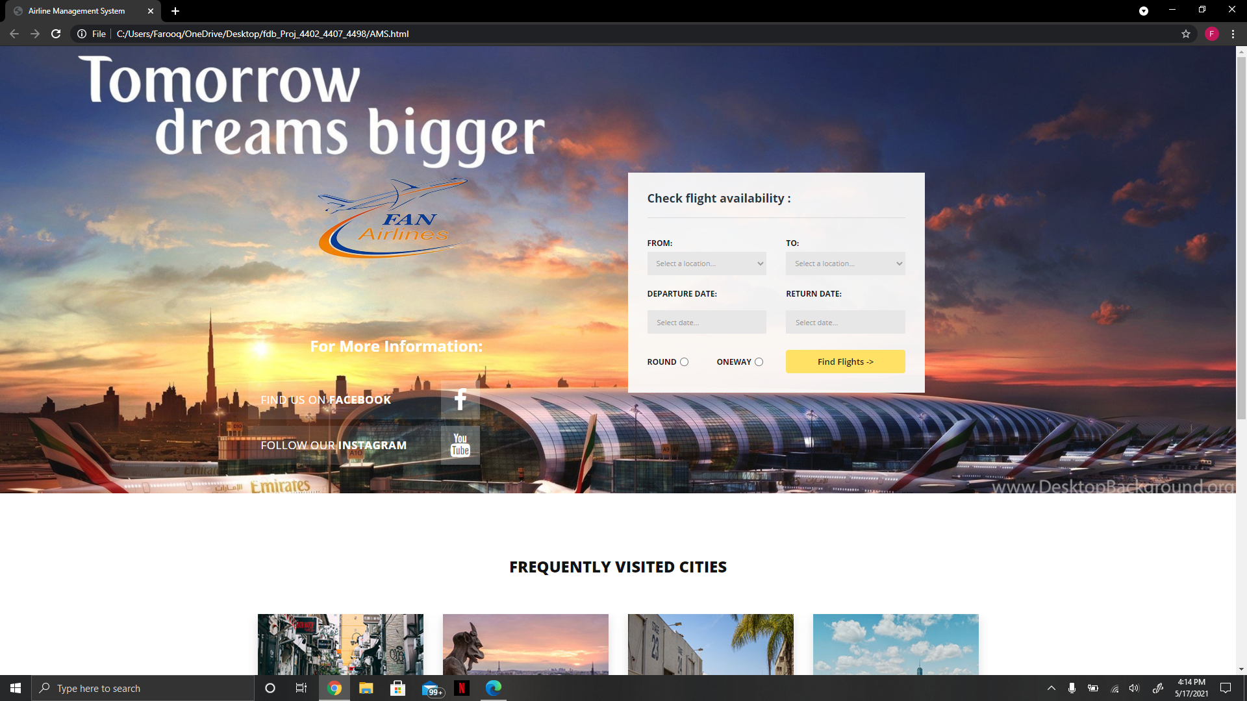

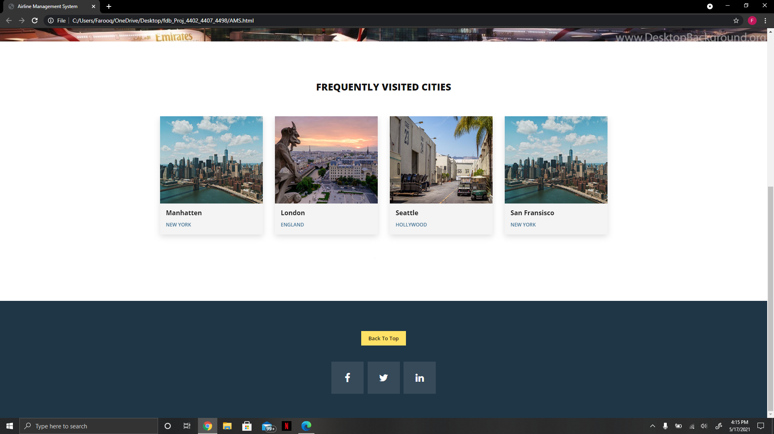

References

https://app.diagrams.net/?src=about
https://www.youtube.com/watch?v=YNSnugnQYiI
https://www.youtube.com/watch?v=CDe5wfHAlAY
Fundamentals of Database Systems (7th edition)
https://www.w3schools.com/tags/att_style.asp

